Science, Technology, and Engineering
Day 13-15: Unit Review
Vocabulary
Fill in the blank with the term that best completes the sentence.
1. A(n) ________________________________________ is a factor that is not allowed to change.
2. A _________________________________ is a description of something that includes a number and a unit.
3. The sum of all values in a data set divided by the total number of values in the set is the ____________________.
4. A scientific __________________________________ is a well-supported and widely accepted explanation of nature.
5. __________________________________ is the application of science and math to solve real-life problems.
Key Concepts
Choose the letter of the best answer.
6. Which of the following is a scientific question?
A. Which plant is my favorite?
B. Why do plants grow taller in sunlight?
C. Which plant looks best in this room?
D. Which plant will sell well in the store?
7. Scientists use which one of the following units to measure mass?
A. pounds
B. meters
C. kilograms
D. ounces
8. All of the following products are the result of using the engineering design process. Which product was engineered to address needs of a person who has lost a body part such as an arm or a leg?
A. lasers
B. prosthetics
C. steam engine
D. voice-recording devices
9. The table shows events that led to the current theory that the sun is the center of the solar system.
Event
1 | Scientists observe planetary motion that cannot be explained if Earth is the center of the universe.
2 | Scientists accept the theory that the planets and sun travel around Earth.
3 | Scientists develop the theory that the planets travel around  the sun.
Which sequence of events is correct?
A. 1, 2, 3 C. 2, 1, 3
B. 1, 3, 2 D. 3, 1, 2
10. Good experiments follow organized procedures. Which of these phrases describes another characteristic of a good scientific experiment?
A. repeated trials
B. uncontrolled surroundings
C. small sample size for collecting data
D. variable procedures for obtaining data
11. Controlled scientific experiments include variables. One kind of variable is an independent variable, and the other kind is a dependent variable. Which statement describes the difference between an independent variable and a dependent variable?
A. The dependent variable does not change, and the independent variable does change.
B. The independent variable does not change, and the dependent variable does not change.
C. The dependent variable is the control, and the independent variable is the result.
D. The dependent variable changes based on the independent variable.
12. Which is a tool that scientists would least likely use in a lab?
A. test tube
B. hot plate
C. electron microscope
D. yardstick
13. Neil drops a ball from four different heights. The table shows how long it took the ball to reach the ground each time.
Time to Drop from Various Heights
Trial | ? | Time  (s)
A | 5 | 1
B | 20 | 2
C | 40 | 3
D | 80 | 4
Which of the following is the best label for the second column?
A. Speed
B. Mass of the ball
C. Height (m)
D. Length of drop
Critical Thinking
Answer the following questions in the space provided.
14. Explain how a scatter plot can be used to show precision in data measurements.

15. A biologist used the terrarium below to model the interactions of plants and animals in a forest ecosystem.
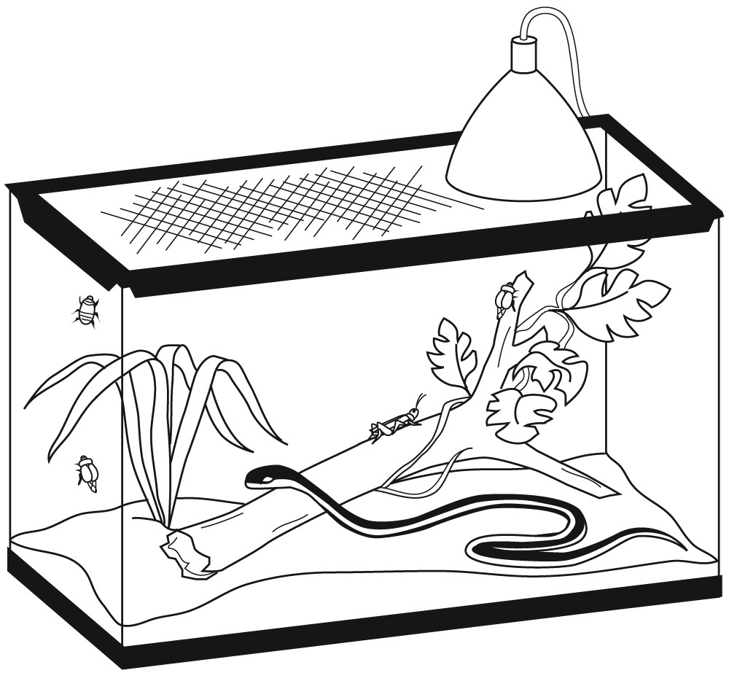
Identify one benefit of using this model to study organism interactions.

Identify one limitation of using this model to study organism interactions.

 ESSENTIAL QUESTIONS
Lessons 2 and 3
Answer the following questions in the space provided.
16. One student thinks that marigold plants grow better when they receive 10 h of light each day. Another student thinks they grow better with only 8 h per day. Design an experiment that could test this idea. Identify the independent variable and the dependent variable, and describe how the data will be collected, describe how it will be controlled, and show how the data should be recorded.

